IOT BASED EARLY FLOOD DETECTION

AND ALERT

# 

**DESCRIPTION;**

Natural calamities are increasing day by day everywhere in the world it is affecting the economy of the country. Economy and the growth of the country depends upon the agriculture of the country by the natural calamities like flood which is mainly affecting the agriculture and which in turn resulting in the financial stability of the farmers as well as the country’s economy. Many regions are continuously affecting every year so to control these or to take precautions before it happens we need the help of the new technology. This project proposes a very much utilized for monitoring the water level, flow variations in the river using sensors and it can be used in the dams and reservoirs. We can prevent natural disaster caused by the flood, with the aid of an IOT based early flood related parameter monitoring and detection system. First the hardware is placed in the flood prone areas, if the water level rises it gives alert messages immediately. In summary, it will help in the community in taking quick decisions and planning againstthe disaster.

**Keywords:** Internet Of Things (IOT), Sensors

**PROJECT IMPLEMENTATION;**

The sensors used in this model are water level sensor, Temperature and Humidity sensor, Soil moisture sensor, Water flow sensors. Every sensors are set into a desired value so we can identify the values or the current rating form the sensors, if the values exceeded the threshold value alert signals will be produced and people will identify this as a warning or a situation to take appropriate measures to prevent or overcome the flood.

The DHT11 is a basic, ultra-low-cost digital temperature and humidity sensor. It uses a capacitive humidity sensor and a thermostat to measure the surrounding air, and spits out a digital signal on the data pin (no analog input pins needed).

Water flow sensor consists of a plastic valve from which water can pass. A water rotor along with a hall effect sensor is present the sense and measure the water flow.

The working of the water level sensor is pretty straightforward. The series of exposed parallel conductors, together acts as a variable resistor (just like a potentiometer) whose resistance varies according to the water level. The change in resistance corresponds to the distance from the top of the sensor to the surface of the water. The resistance is inversely proportional to the height of the water. The resistance is inversely proportional to the height of the water. The more water the sensor is immersed in, results in better conductivity and will result in a lower resistance. And all the values are displayed in a LCD display.

**CIRCUIT DIAGRAM;**

* 1. 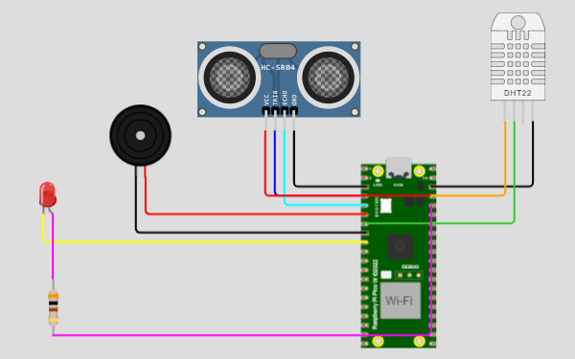
  2. **MODELLING & ANALYSING**

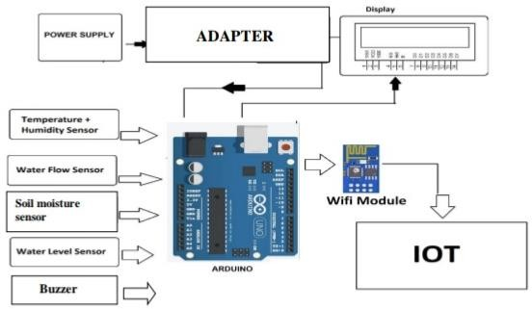

# SIMULATION PROCESS;

# The Simulation for the Implementation of Early Flood Detection and avoidance System using LORA was done using Proteus 8 Professional. The above figure shows the overall setup of simulation process

# 

### Fig: Result of the Simulation process

**ARDUINO UNO R3**

Arduino is an open-source electronic platform that is based on connection between hardware and software and it is easy to use and implement. They are designed in such a way that it read the input– water reaches a certain threshold and turn it into an output – sending the alert. The Arduino Uno is a microcontroller board based on the ATmega328. It has 20 digital input/output pins (of which 6 can be used as PWM outputs and 6 can be used as analog inputs), a 16 MHz resonator, a USB connection, a power jack, an in-circuit system programming (ICSP) header, and a reset button. It contains everything needed to support the microcontroller; simply connect it to a computer with a USB cable or power it with an AC-to-DC adapter or battery to get started.

* 1. **WI-FI MODULE – ESP8266**

The ESP8266 Wi-Fi Module is a self-contained SOC with integrated TCP/IP protocol stack that can give any microcontroller access to your Wi-Fi network. The ESP8266 is capable of either hosting an application or offloading all Wi-Fi networking functions from another application processor. Each ESP8266 module comes pre-programmed with an AT command set firmware, meaning, you can simply hook this up to your Arduino device and get about as much ability as a Wi-Fi Shield offers (and that's just out of the box) The ESP8266 module is an extremely cost effective board with a huge, and ever growing, community. The ESP8266 Module is not capable of 5-3V logic shifting and will require an external Logic Level Converter. Please do not power it directly from your 5V dev board. This new version of to 1v.

Program:

import time

import machine

import dht

# Define GPIO pins

TRIG_PIN = machine.Pin(2, machine.Pin.OUT)

ECHO_PIN = machine.Pin(3, machine.Pin.IN)

BUZZER_PIN = machine.Pin(4, machine.Pin.OUT)

DHT_PIN = machine.Pin(5)

LED_PIN = machine.Pin(6, machine.Pin.OUT)

def distance_measurement():

# Trigger ultrasonic sensor

TRIG_PIN.on()

time.sleep_us(10)

TRIG_PIN.off()

# Wait for echo to be HIGH (start time)

while not ECHO_PIN.value():

pass

pulse_start = time.ticks_us()

# Wait for echo to be LOW (end time)

while ECHO_PIN.value():

pass

pulse_end = time.ticks_us()

# Calculate distance

pulse_duration = time.ticks_diff(pulse_end, pulse_start)

distance = pulse_duration / 58 # Speed of sound (343 m/s) divided by 2

return distance

def read_dht_sensor():

d = dht.DHT22(DHT_PIN)

d.measure()

return d.temperature(), d.humidity()

buzz_start_time = None # To track when the buzzer started

while True:

dist = distance_measurement()

temp, humidity = read_dht_sensor()

# Check if the distance is less than a threshold (e.g., 50 cm)

if dist < 50:

# Turn on the buzzer and LED

BUZZER_PIN.on()

LED_PIN.on()

status = "Flooding Detected"

buzz_start_time = time.ticks_ms()

elif buzz_start_time is not None and time.ticks_diff(time.ticks_ms(), buzz_start_time) >= 60000: # 1 minute

# Turn off the buzzer and LED after 1 minute

BUZZER_PIN.off()

LED_PIN.off()

status = "No Flooding Detected"

else:

status = "No Flooding Detected"

print(f"Distance: {dist:.2f} cm")

print(f"Temperature: {temp:.2f}°C, Humidity: {humidity:.2f}%")

print("Status:", status)

time.sleep(2)

* 1. **THING SPEAKWEB SERVER**

According to its developers, Thingspeak is an open-source Internet of Things (IOT) application and API to store and retrieve data from things using the HTTP and MQTT protocol over the Internet or via a Local Area Network. Thingspeak enables the creation of sensor logging applications, location tracking applications, and a social network of things with status updates. ThingSpeak has integrated support from the numerical computing software MATLAB from Math

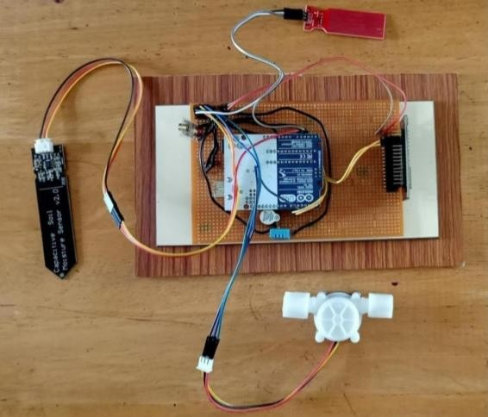Works, allowing ThingSpeak users to analyze and visualize uploaded data using Matlab without requiring the purchase of a Matlab license from Math works.

## APPLICATIONS

* + Able to check water level on a remote place autonomously.
  + Collect data on water level status from all locations and send it to a central server.
  + Have a web-based system that users may access 24 hours a day, seven days a week via an internet connection.
  + Provide a trending function that displays real- time or historical data.
  + Use a split screen to compare water movement from four distinct locations at the same time.

. A map of the entire monitoring area that shows the current status of each station

**DISCUSSION:**

The proposed model is very much utilized for monitoring of the water level, flow variations, humidity, and temperature variations in the rivers, dams or reservoirs. And the same can be used at drainage systems in cities. In industies and factories, the control panels and transformers are placed in ground levels if an event occurs when the water level raises above the set point then the system will respond.

Advantages of IOT based early flood detection and alert system are,

* Damage can be reduced.
* System performance can monitered through internet.
* At emergency conditions necessary actions can be taken
* Highly reliablility as data is send in real time.

Disadvantages of IOT based early flood detection and alert system are,

*Inability to produce highly accurate result.

* Is there is no sufficient data ,flood prediction would be difficult .
* They do not stop land from flooding they warn peoples that a flood is likely. .
* **CONCLUSION**

This project highlights the possibility to provide an alert system that will overcome the risk of flood. As the project is enabled with IOT technology and hence the sensor data can be monitored from anywhere in the world. More sensors can be integrated into the system in order to create more accurate and efficient flood detection system. It can also contribute to multiple government agencies or authority that ultimately help the society and mankind about the flood like hazardous natural disaster. It will monitor each and Severy aspect that can lead to flood. If the water level rises along with the speed, it will send an alert immediately. It also ensures increased accessibility in dealing and reverting to this catastrophic incident. In summary, it will help the community in taking quick decisions and planning against this disaster mankind about the flood like hazardous natural disaster